Verify Identify

Video Demo - https://getnametag.com/how-to-verify

- Go to the self-service link, https://coke.com/recovery. Enter your work email on the Coca-Cola-branded web page.
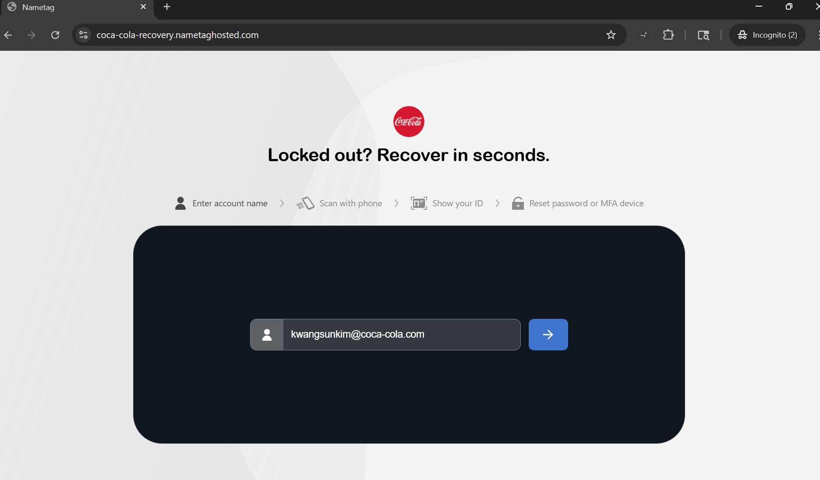

- After typing in your work email and clicking the “Next” button, the web page will display a QR code that you can scan using your work or personal smartphone.
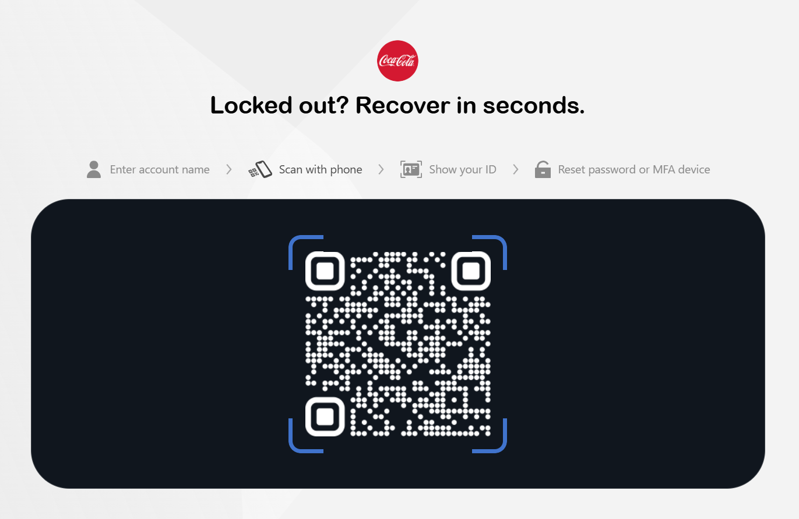

- After scanning the QR code from the smartphone, the Nametag Icon is prompted up, and you will need to follow through the whole process as it is presented on your smartphone. Select Open to begin.
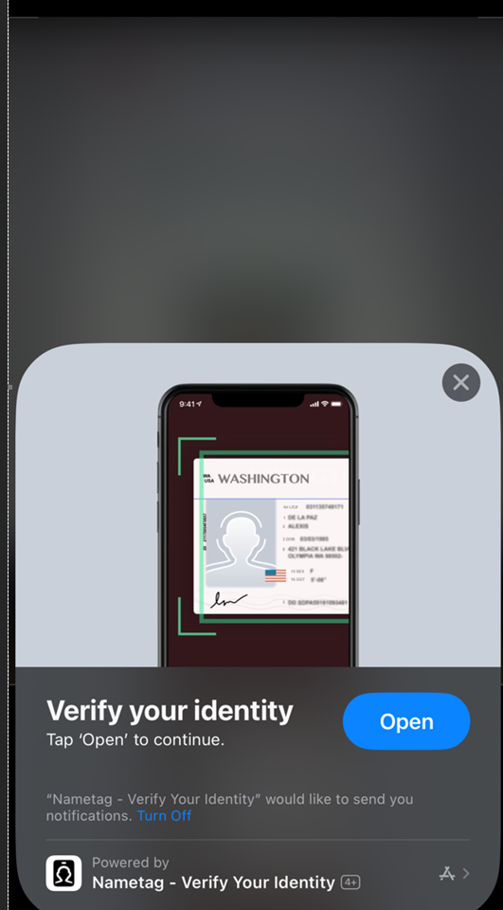

- Select the plus sign to start scanning. Select Scan Now and allow Nametag to access your phone’s camera.

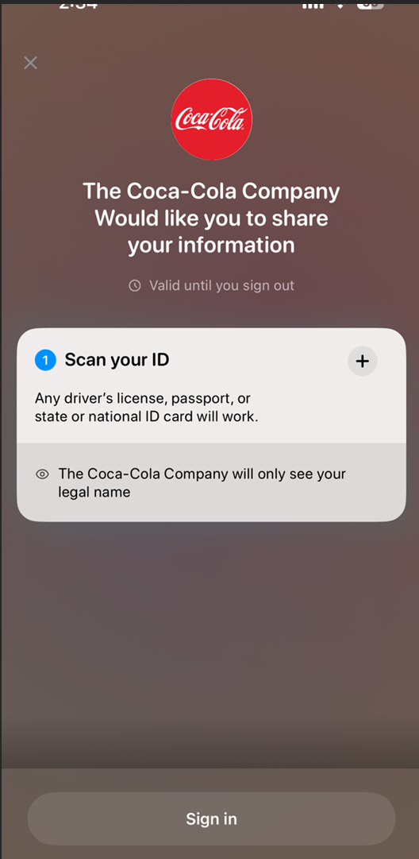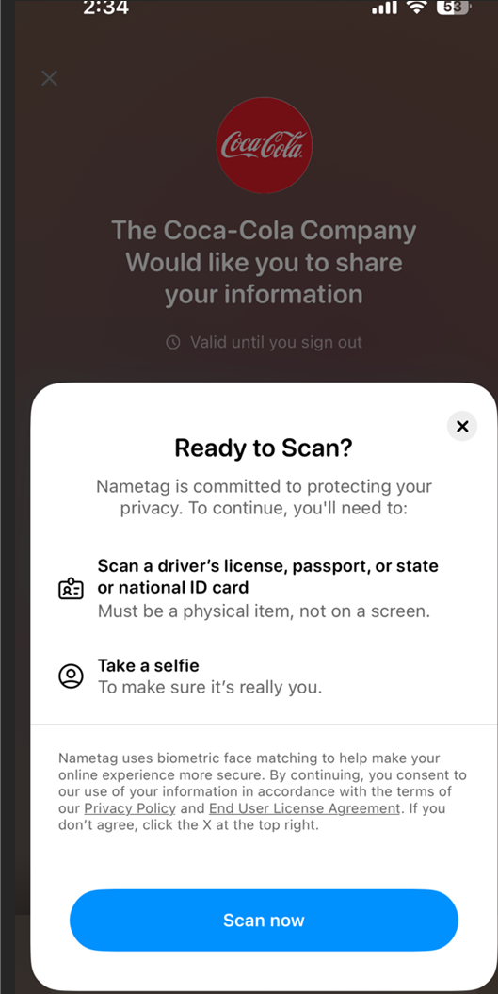

- Follow the prompts to scan your ID and take a selfie.
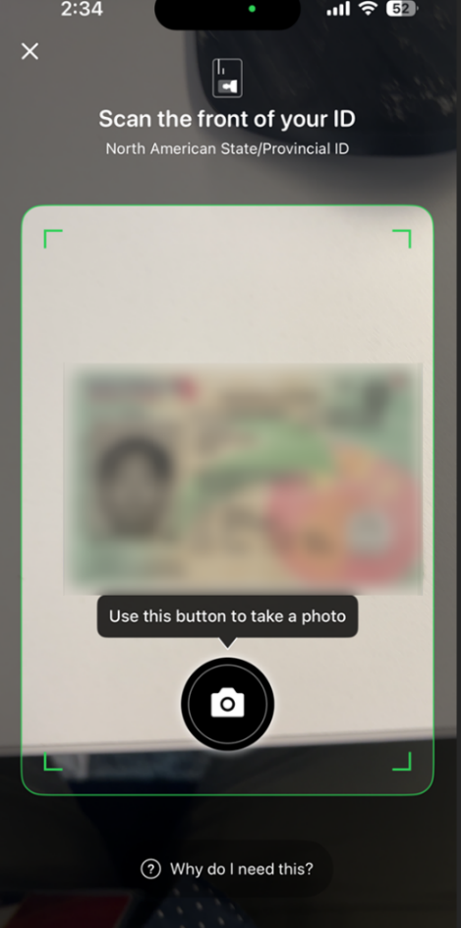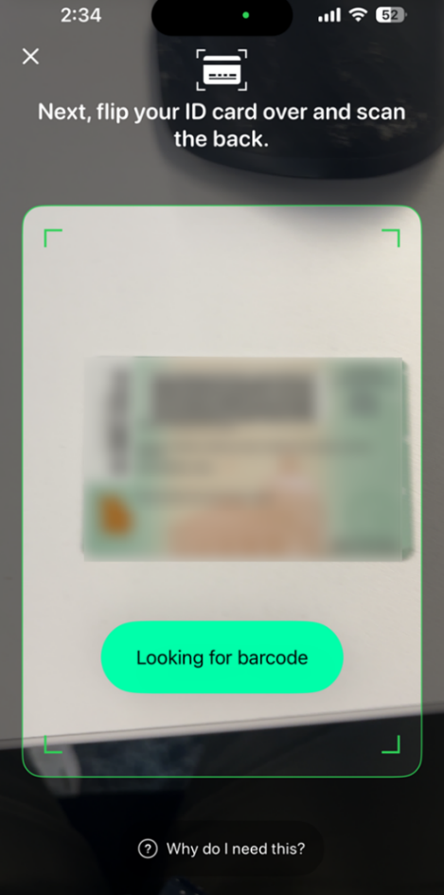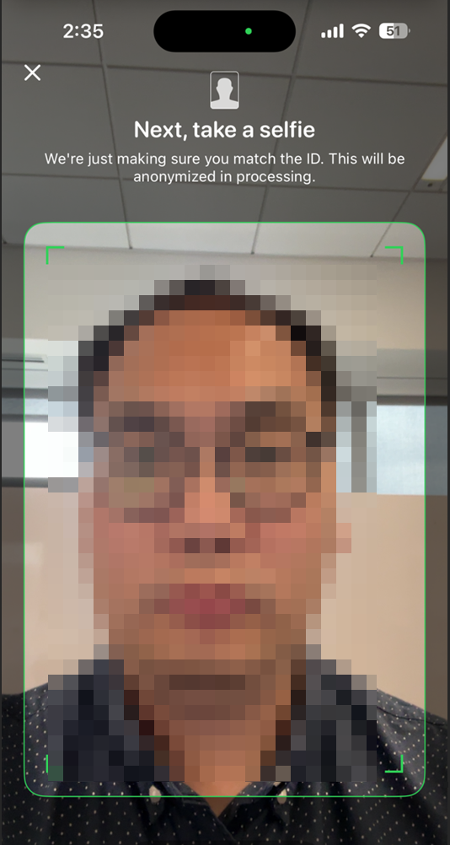

- After the selfie process, select Sign in and then Close.

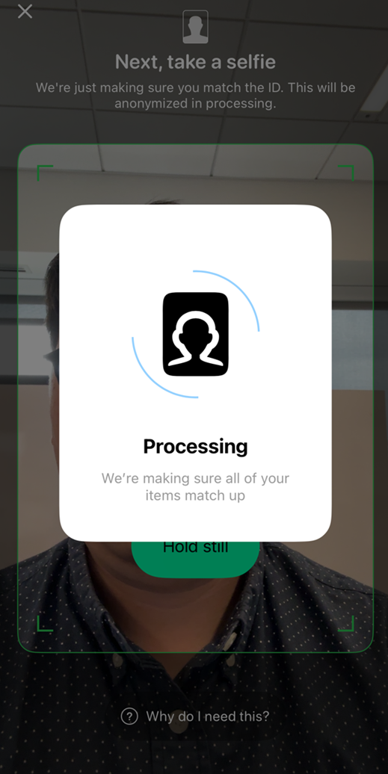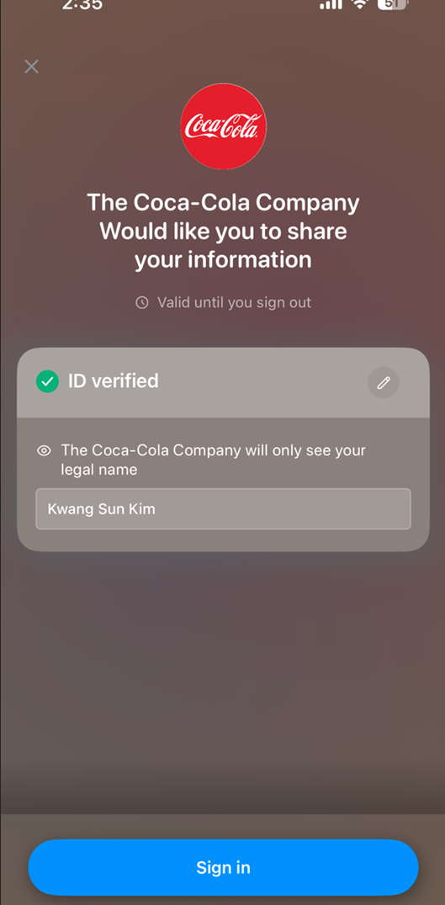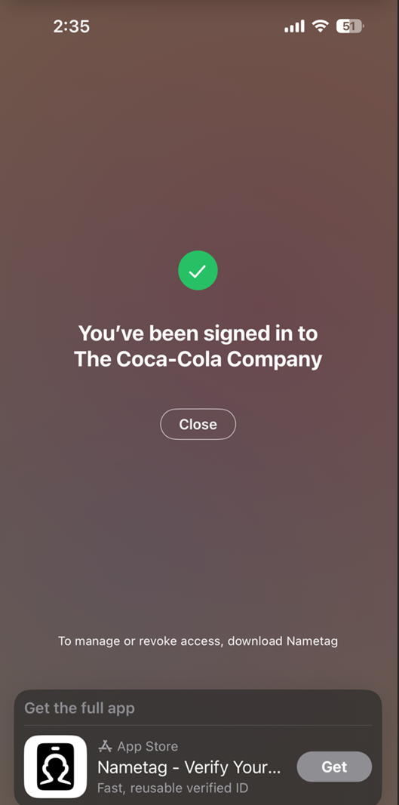

Reset MFA
- After the successful verification, the web page is redirected to the MFA reset page. Choose the MFA reset buttons to proceed with the reset.
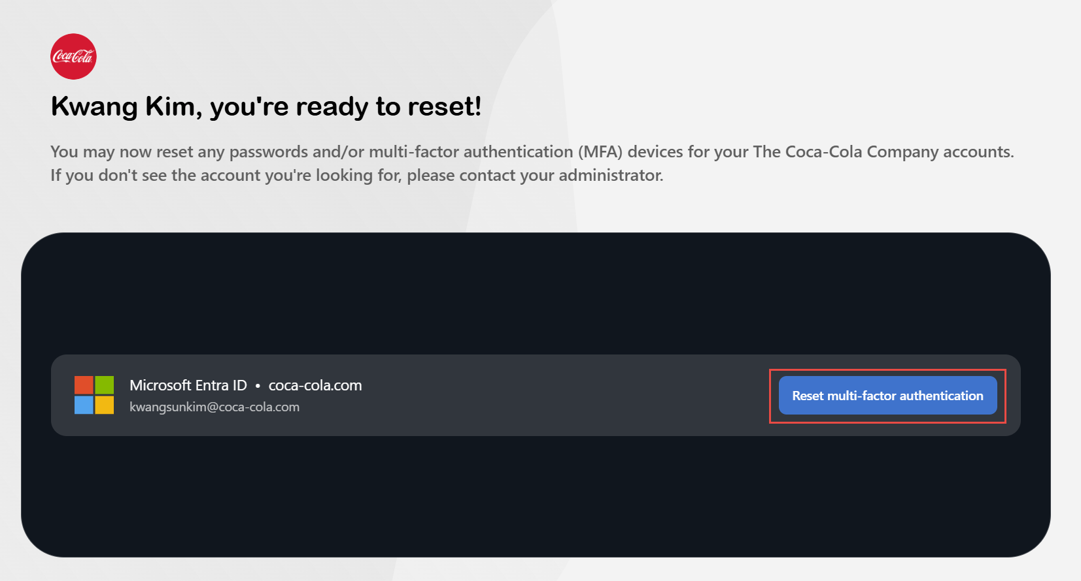

- After clicking the MFA reset button, it will prompt you to reset the token. Please select “Yes, reset tokens” to proceed.
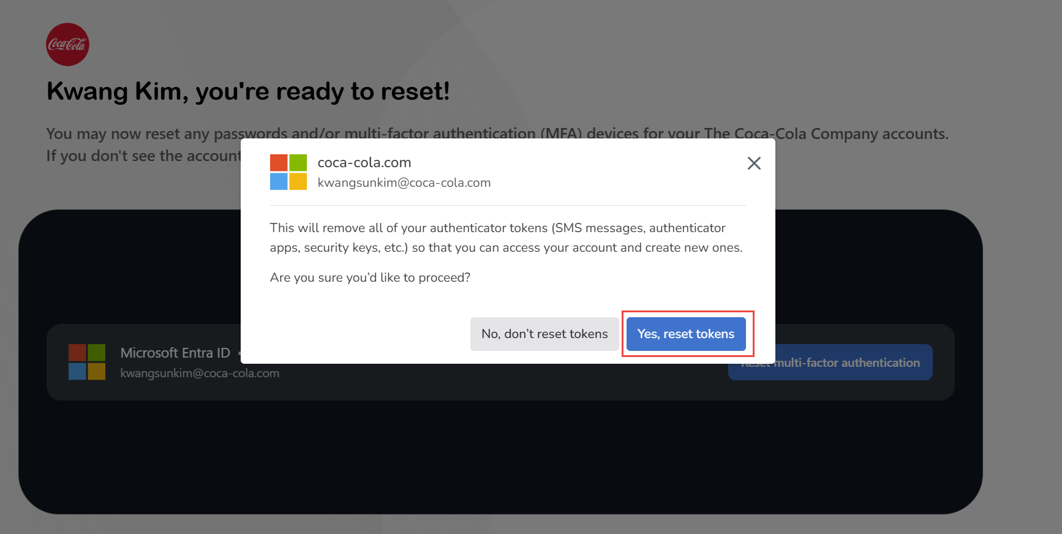

- Access the link present in the prompt box.
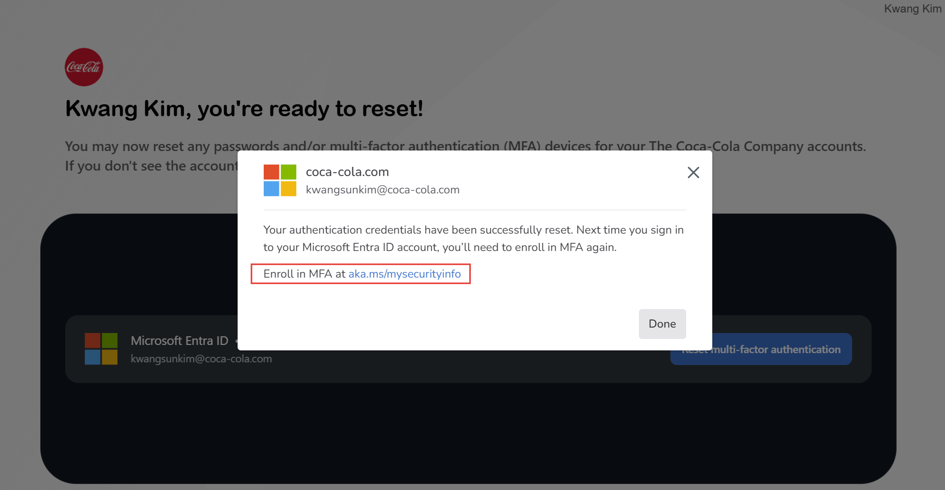

- It would prompt for the username and password. Make sure to select “Use Your Password Instead” to authenticate.
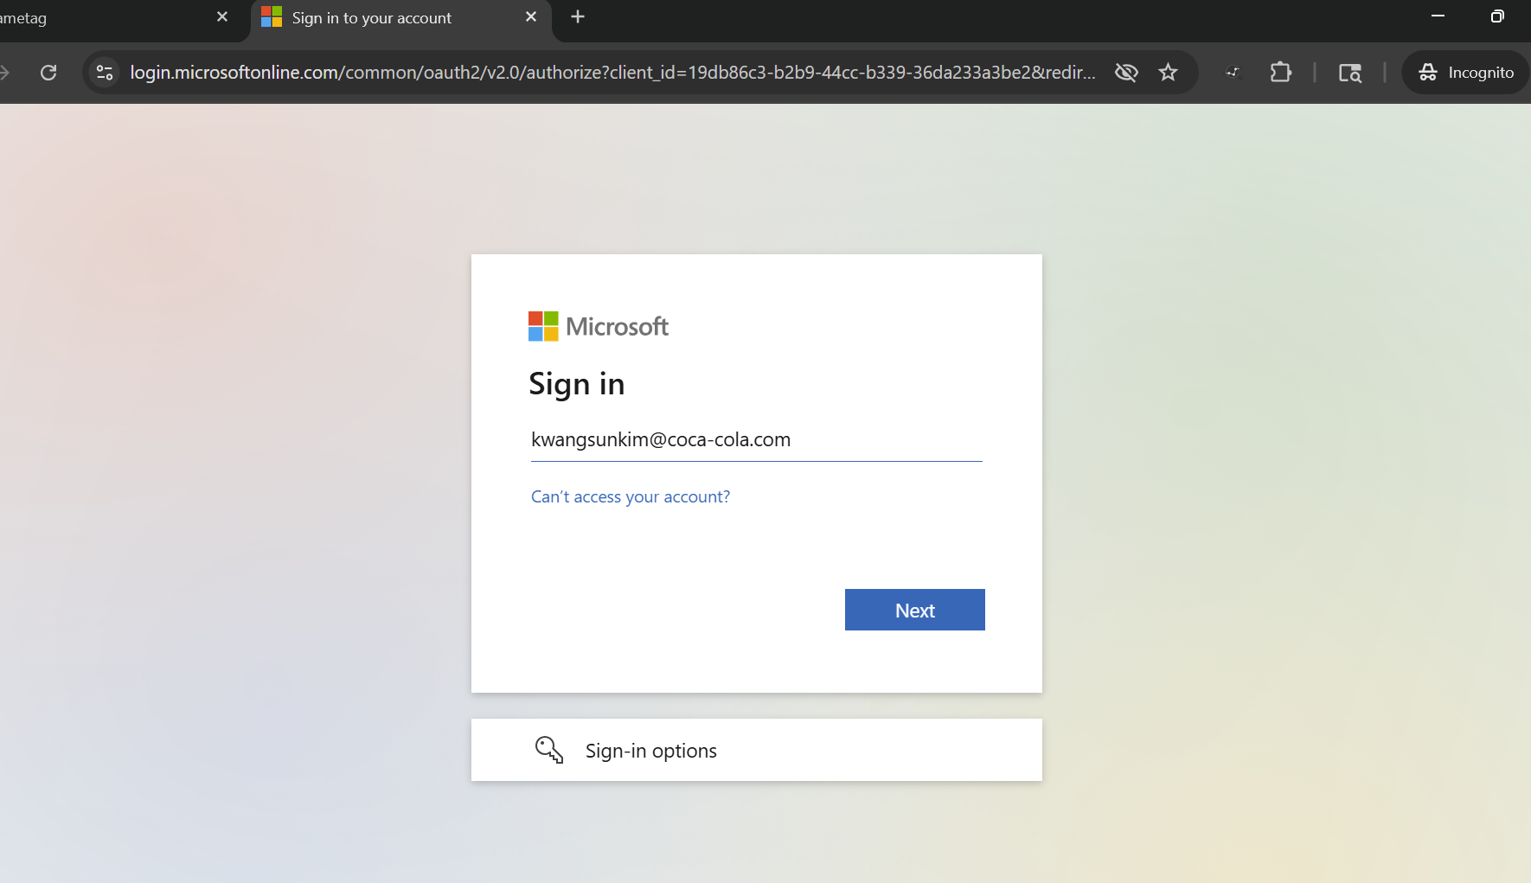

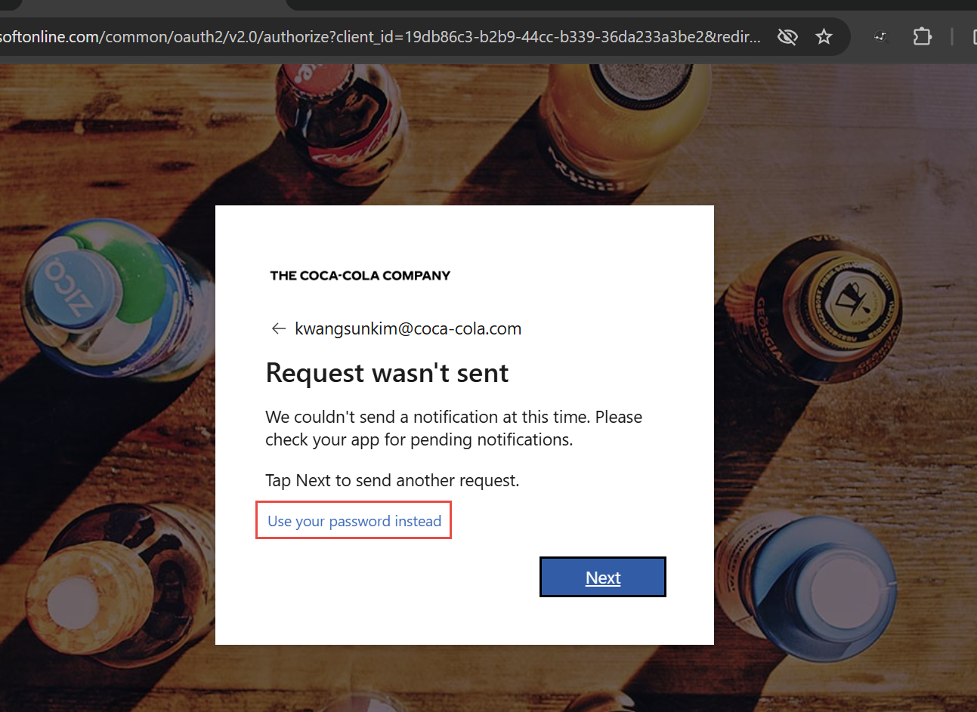
- After authenticating, it will prompt you to set a new MFA method for your account. Click “Next” and proceed to setting up the MFA method, such as the Microsoft Authenticator App.
